How to Access UB's Child Protection Policy Course
Follow the instructions below to take the online training course via UB Learns
UB Learns Website Link: https://ublearns.buffalo.edu/
*Important note: This course will not work when using the Internet Explorer (IE) web browser.
Verify that your internet browser is compatible. To use UB Learns, use a computer that is connected to the Internet and use an up-to-date web browser. It is recommended that you use the most current version of:
Chrome Firefox
Safari Microsoft Edge
Blackboard technical support offers a list of certified and compatible browsers, listed by Operating System, for use with Blackboard (UB Learns). Blackboard Compatible Browsers(UB Learns).
Accessing the Course
- Go to UB Learns and select “Login”.
Enter your UBITName and password Click “Login”.
To look up your UBIT Name please go to: https://www.buffalo.edu/search/you

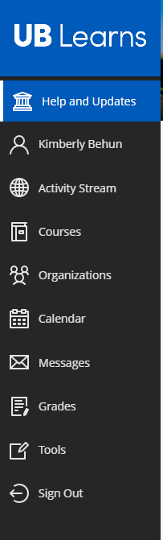
- Select “Courses” in the left navigation menu.
If you do not see the left navigation menu, make sure you are viewing the page in a full screen.
- Select the UBLearns “Course Catalog” link that is displayed on the top-right of the page.
Search for the course by entering ub child in the text box and then select “Go”.
The UB Child Protection Policy Training Course will be displayed.

- Self-Enroll in the course.
  - Select course ADM_EDI_Child_Protection and a down arrow will appear.
  - Select the down arrow and then Enroll(will only see the down arrow by hovering over the name).
  - Click Submit to proceed.
A window will appear confirming you have successfully enrolled in the course.
  - Select the OK link found at the bottom right side of the screen to continue to the course.
- To start the course:
Select the UB Child Protection Policy Training link.
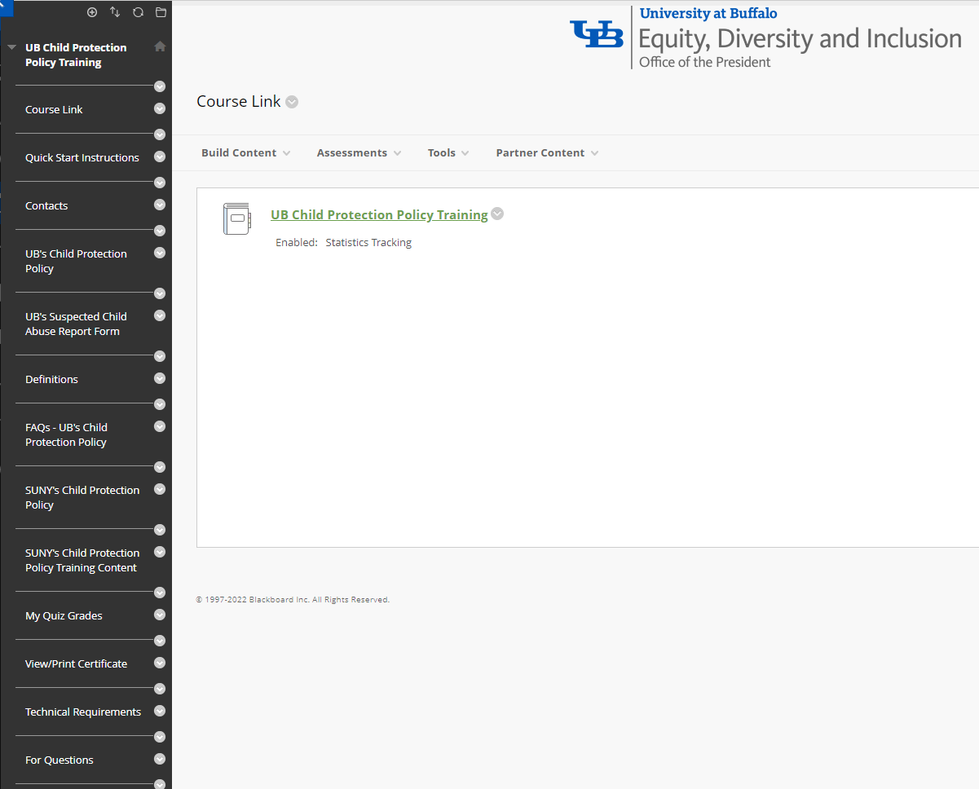

- To navigate the course, use the right arrow through the course pages.
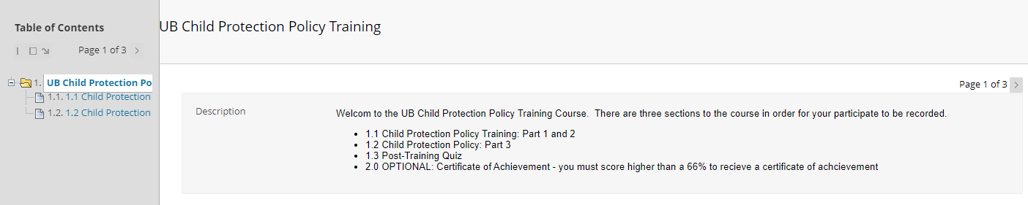
- Page 2: Play the Child Protection Policy Training: Part 1 & Part 2 video.
Start the training by selecting the play button in the middle of the screen.
You may choose to watch the video by watching the video in Panopto or by making the video full sized. You may also change the speed of the video or turn the captions on or off.
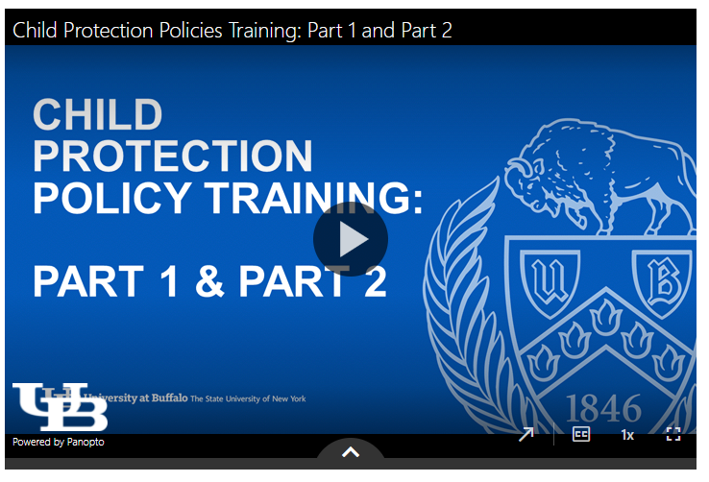
Full Screen
Video Speed
Captions
Watch in Panopto

  - Panopto is the video platform that was used to create the training video. The software requires your internet browser to accept third-party cookies. The Safari internet browser in particular may require you to change your settings in order to view this type of video file.
If you are using an Apple device (i.e. MacBook, iMac, iPad or iPhone) and the Safari browser, please review the following information regarding Panopto and the Safari internet browser:
How to enable support for Third Party browsers

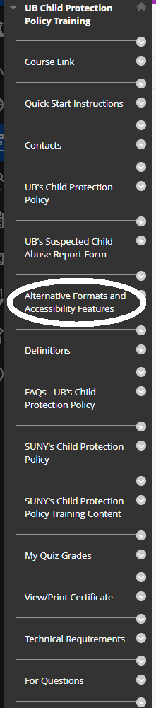
  - Alternative Formats and Accessibility Features:

  - For additional information, refer to the Alternative Formats and Accessibility Features found in the left navigation menu.
When you have finished the video, please select the arrow to the right of the number 3.

- Page 3: Play the Child Protection Policy Training: Part 3 video.
- Page 4: Post Training Quiz
If the quiz does not automatically launch, please select the Click to Launch link.
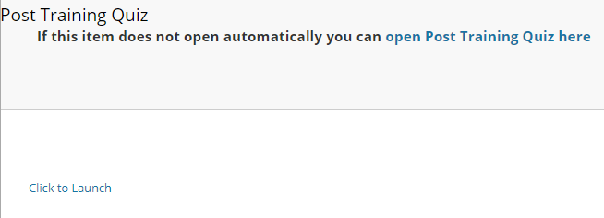
- Take the quiz.
  - Select the Begin link that is displayed on the bottom right of the page.
  - Answer all the questions displayed.
  - Select the Save and Submit link displayed on the bottom right of the page.
  - A “test submitted” message will appear.
  - Select the OK link displayed on the bottom right of the page.
  - Your quiz score and graded answers are displayed along with an explanation for each question.
  - You are required to achieve a minimum of four correct answers (above 66%) to complete the course. If you did not achieve this, you may select the OK link displayed on the bottom right of the page and relaunch the quiz to try again.
  - Once you have achieved a passing quiz score, select the OK link displayed on the bottom right of the page. You have completed the course, and your completion record will automatically register. You’ve completed the course!

* To view your quiz grade:
- To view your quiz grade, select My Quiz Grade, from the left navigation menu in UB Learns.
- Select My Grades. Your grade will be displayed.
- You may retake the quiz if your grade is below a 66%.
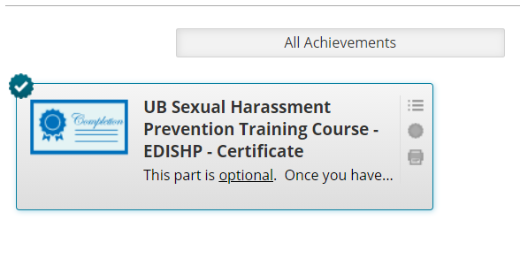
*Optional Certificate of Completion:
You do not need to submit a Certificate of Completion to the Office of Equity, Diversity and Inclusion (EDI). Your completion will be automatically recorded upon completion of the previous steps.
If you would like to create and/or print a Certificate of Completion for your own records or to provide to another employer, select View/Print Certificate in the left navigation menu in UB Learns.
To print your certificate, select the printer icon.
Sign out of UB Learns
- Select Sign Out in the left navigation menu in UB Learns.
- Close all internet tabs.

For Mobile Phones or Tablets - Accessing UB Learns from your portable device
UB Learns does not support enrollment in the course on its mobile app. Please take the annual Sexual Harassment Prevention Training on a desktop, PC, or laptop device. If you are unable to do so, please contact EDI for assistance.
Accessibility:
The University at Buffalo strives to create accessible content for all. The University at Buffalo will provide reasonable accommodations to ensure individuals with disabilities have equal access to the training content. To request accommodations, please contact Equity, Diversity and Inclusion (EDI) by email at diversity@buffalo.edu or by phone at (716) 645-2266 for assistance.

